1. PC direct connect to Module. And set fixed IP：192.168.0.X

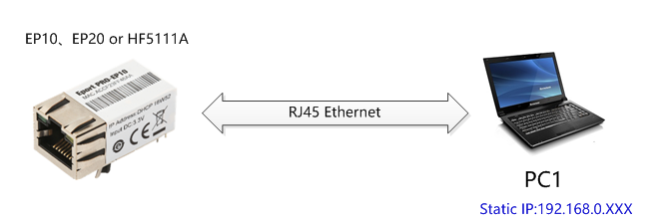

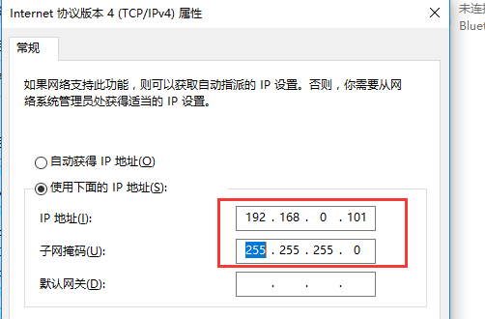

1. Put UART upgrade firmware into the TFTP "D:\Cisco TFTP Server.rar\down" directory. Such as following.

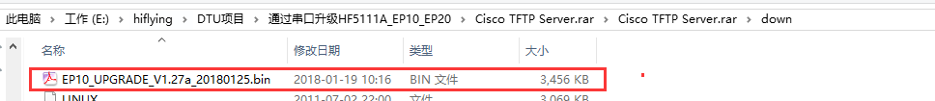

Set tftp Server directory to the above down directory.

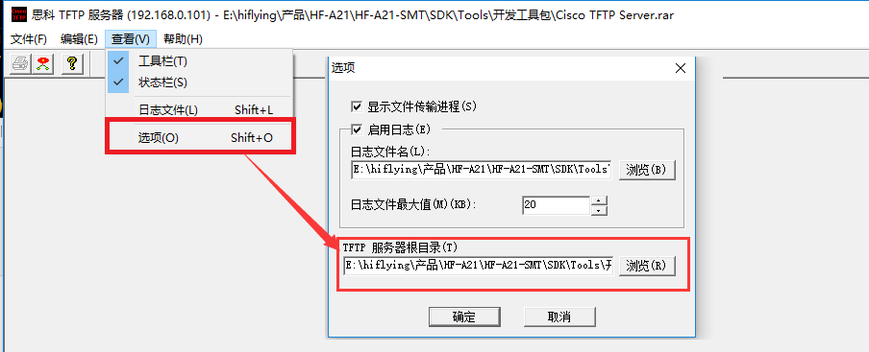

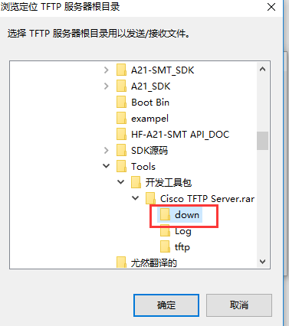

Then run“TFTPServer.exe”.

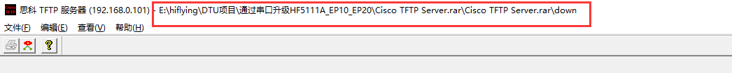

1. Power On or Reset module and continues click keyboard "Enter" key until enter the booloader mode as following pic.（UART baud rate 115200，8，No flow control，1）

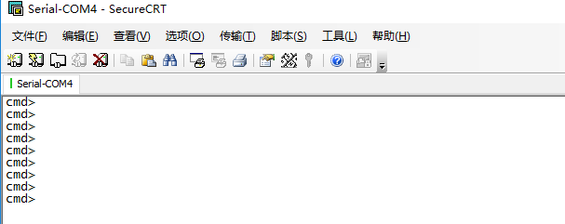

 4. After the module enter bootloader mode, then set the following command ：

cmd>set server 192.168.0.101 （PC IP address）



cmd>tftp get EP10_UPGRADE_V1.27a_20180125.bin （firmware name）

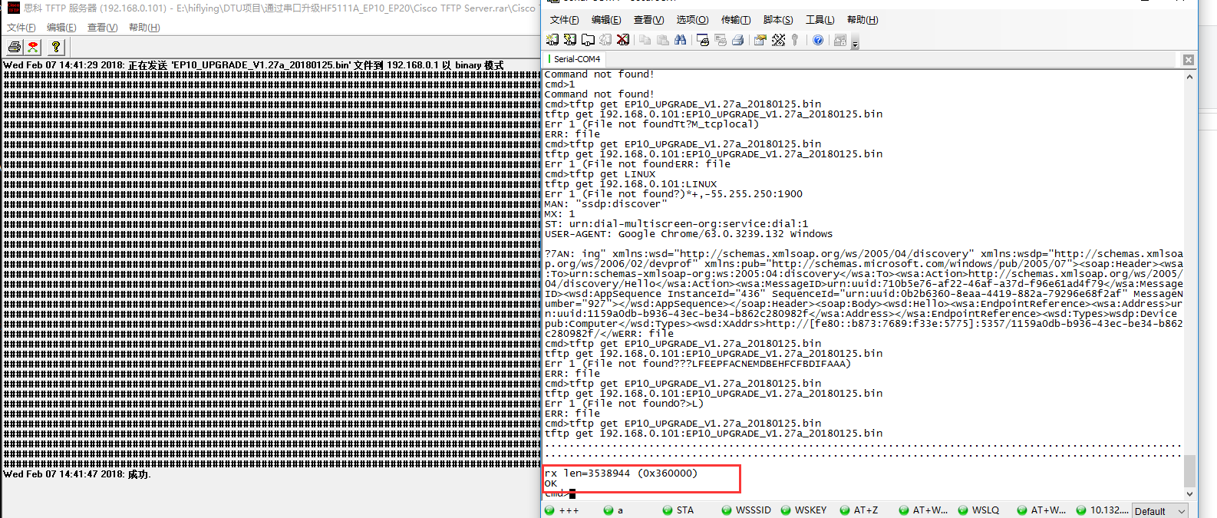

cmd>fa （Writethe download firmware into module flsh）



5. Reboot module and finish upgrade.